CS-114 - Fundamental of Programing

ASSIGNMENT-1

**Course Instructor:** Dr Jawad Khan

**Lab Instructor:** Muhammad Affan

## Student Name: Ahmed Adil Hussain

## CMS ID: 477537

**DATE:**

**20 November 2023**

**TASK 1:**

1. Write a C++ program to display factors of a number using for loops.

**Code:**

#include <iostream>

using namespace std;

int main()

{

// TASK 1

int num;

cout<<"Please enter the number"<<endl;

cin>>num;

cout<<"The factors are: ";

for(int f=1; f<=num; f+=1){

// to put a full stop at the end instead of a comma

if(f==num){cout<<f<<"."; break;}

if(num%f == 0){cout<<f<<", ";}

}

return 0;

}

**Result:**

**TASK 2:**

**OUTPUT:**

x is 5 and y is 10

**TASK 3:**

3. Write a C++ program, take an integer value from user and check if it’s greater than 10 and less than equal to 20. Print 1 if yes and print 0 if no. Use appropriate datatype for output.

**Code:**

#include <iostream>

using namespace std;

int main()

{

// TASK 3

int x;

cout<<"Please enter the number"<<endl;

cin>>x;

if(x>10 && x<20){cout<<1<<endl;}

else{cout<<0<<endl;}

return 0;

}

**Result:**

**TASK 4:**

4. Write a C++ program that uses a while loop to find the largest prime number

less than a given positive integer N. Your program should take the value of N as

input from the user and then find the largest prime number less than or equal to

N. You are not allowed to use any library or pre-existing functions to check for

prime numbers.

**Code:**

#include <iostream>

using namespace std;

int main()

{

// TASK 4

int n;

int prime;

cout<<"Please enter the number"<<endl;

cin>>n;

for(int i=n; i>=2; i-=1){

for(int j=2; j<=i; j+=1){

if(i%j==0 && i==j){prime = j;}

if(i%j==0){break;}

}

if(prime == i){break;}

}

cout<<"The largest prime is: "<<prime<<endl;

return 0;

}

**Result:**

**TASK 5:**

5. Write a C++ program, take two string as input from user and check if both

strings are equal or not. If they are equal make them unequal by rotating string.

e.g., Hello is turned into olleH etc.

**Code:**

#include <iostream>

#include <cstring>

using namespace std;

int main()

{

// TASK 5

char st1[10];

char st2[10];

cout<<"Please enter the strings"<<endl;

cin>>st1;

cin>>st2;

int p = strlen(st2)-1;

char st3[p];

// st3[10] = st2[10];

// cout<<"st3 "<<st3;

if(strcmp(st1, st2)==0){

for(int i=0; i<10; i+=1){

st3[p]=st2[i];

p=p-1;}

cout<<"The reversed string is: "<<st3<<endl;}

else{cout<<"the strings are not the same"<<endl;}

return 0;

}

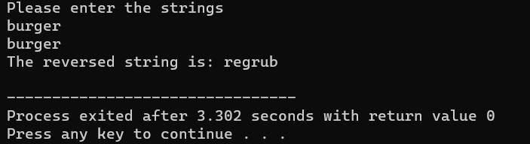**Result:**

**TASK 6:**

6. Perform division in C++ without / using for loops. You can use / only to display

the final results. Your dividend must be greater than divisor.

**Code:**

#include <iostream>

using namespace std;

int main()

{

// TASK 6

int dd;

int dv;

int q;

int rem;

int dd2;

cout<<"a and b in a/b?? (a must be greater than b)"<<endl;

cin>>dd>>dv;

if(dv>dd){cout<<"Please follow the provided guideline."<<endl;}

else{

for(int i=0; i<=dd; i+=1)

if((dd-i)%dv==0){rem=i; dd2=dd-i; break;}

for(int j=0; j<=dd2; j+=1)

if(j*dv == dd2){q=j; break;}

cout<<"The quotient is "<<q<<endl;

cout<<"The remainder is "<<rem<<endl;

}

return 0;

}

**Result:**

**TASK 7:**

7. Write a C++program for a string which may contain lowercase and uppercase

characters. The task is to remove all duplicate characters from the string and find

the resultant string.

**Code:**

#include <iostream>

#include <cstring>

using namespace std;

int main()

{

// TASK 7

int ls;

char str[ls];

cout<<"Enter the string"<<endl;

cin>>str;

for(int i=0; i<=ls; i+=1){

if(str[i] == str[ls-i]){str[ls-i] = ' ';}

}

for(int j=0; j<=ls; j+=1){

if(str[j]==' '){str[j]=str[j+1]; str[j+1]=' ';}

}

cout<<"The resultant string is: "<<str;

return 0;

}

**Result:**

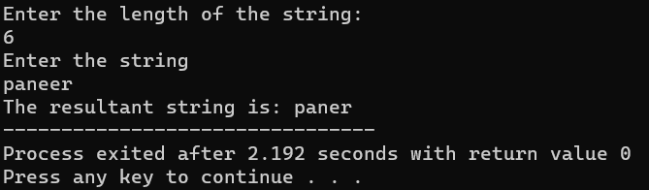

**TASK 8:**

8. Suppose an integer array a[5] = {1,2,3,4,5}. Add more elements to it and

display them in C++.

**Code:**

#include <iostream>

using namespace std;

int main()

{

// TASK 8

int l;

cout<<"How many more elements do you want to add?"<<endl;

cin>>l;

int a[5+l] = {1,2,3,4,5};

cout<<"Input the elements: "<<endl;

for(int i=5; i<5+l; i+=1){

cin>>a[i];}

cout<<"{";

for(int j=0; j<5+l; j+=1){

// to prevent adding a comma after the final term

if(j==4+l){cout<<a[j];break;}

cout<<a[j]<<", ";}

cout<<"}";

return 0;

}

**Result:**

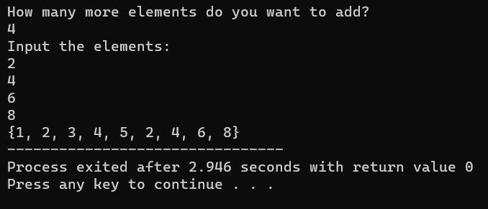

**TASK 9:**

9. Given an integer array and an integer X. Find if there’s a triplet in the array

which sums up to the given integer X.

**Code:**

#include <iostream>

using namespace std;

int main()

{

// TASK 9

int trip[3];

int x;

int l;

cout<<"Please enter the integer"<<endl;

cin>>x;

cout<<"How many integers are to be tested?"<<endl;

// length of string

cin>>l;

int string[l];

cout<<"Input the elements: "<<endl;

for(int i=0; i<l; i+=1){

cin>>string[i];}

// for(int j=0; j<l; j+=1){

// cout<<string[j]<<' ';}

for(int i=0; i<l; i+=1){

for(int j=0; j<x; j+=1){

if(j==i){continue;}

for(int k=0; k<x; k+=1){

if(k==j){continue;}

if(k==i){continue;}

if(string[i] + string[j] + string[k] == x){

trip[0]=string[i];

trip[1]=string[j];

trip[2]=string[k];

break;}

}

}

}

cout<<"The found triplet is: {";

for(int j=0; j<3; j+=1){

cout<<trip[j]<<' ';}

cout<<"}";

return 0;

}

**Result:**

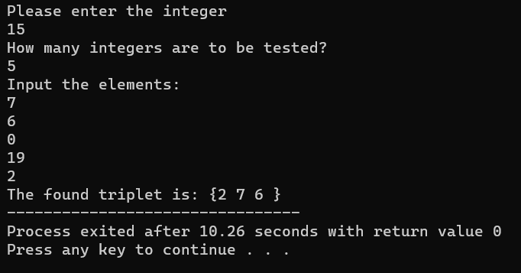

**TASK 10:**

10. Implement Bubble Sort on an array of 6 integers.

**Code:**

#include <iostream>

using namespace std;

int main()

{

/// TASK 10

int a[6];

int bub[6];

int p = 5;

cout<<"Input the elements: "<<endl;

for(int i=0; i<6; i+=1){

cin>>a[i];}

cout<<"The given array is: {";

for(int c=0; c<6; c+=1){

cout<<a[c]<<' ';}

cout<<"}";

for(int z=0; z<6; z+=1){

for(int j=0; j<6; j+=1){

if(a[j]>=a[0] && a[j]>=a[1] && a[j]>=a[2] && a[j]>=a[3] && a[j]>=a[4] && a[j]>=a[5]){

bub[p]=a[j]; a[j]=0; p=p-1;}

else{continue;}

if(a[0]==0 && a[1]==0 && a[2]==0 && a[3]==0 && a[4]==0 && a[5]==0){break;}

}

}

cout<<"The bubble sorted array is: {";

for(int b=0; b<6; b+=1){

cout<<bub[b]<<' ';}

cout<<"}";

return 0;

}

**Result:**